

**HUMAN COMPUTER INTERACTION LAB**

**Lab 13 (Open Ended Lab)**

**Submitted To: Sir Rehan Ahmed**

**Submitted By: Tanzeela Asghar**

**Registration # 2021-BSE-032**

**Semester: VI - A**

**“LAB TASKS”**

**Task 1**

Take “The Weather Channel” App as reference, assume yourself as its competitor to design a new app interface having similar services.

1. Suggest a useful name for your App and design Minimalistic icon for your App. 2. Design all assests required for the app screens

3. Design 5 screens as mentioned in the reference Use accurate measuring of the screen use Iphone X screen for your designs (option available in illustrator, File>new>mobile>iphone X)

**Name:** The Weather Radar

**Logo:**

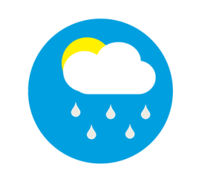

**Screen 1:**

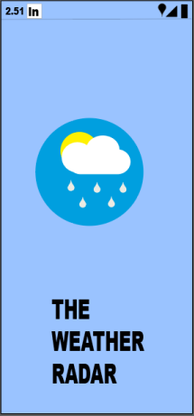

**Screen 2:**

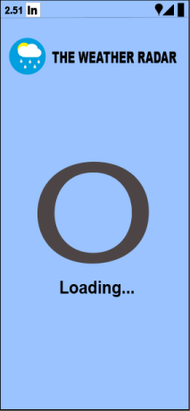

**Screen 3:**

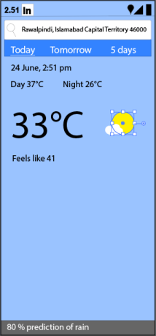

**Screen 4:**

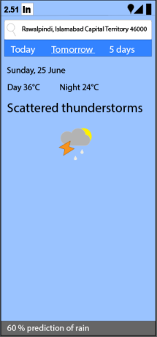

**Screen 5:**

